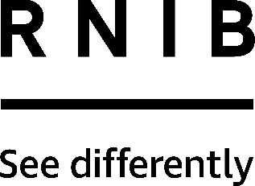

Braille labelling tape (DL104, DL105, DL106)
Thank you for purchasing from RNIB. In the unlikely event the item is unsuitable, please contact us within 14 days of receipt to obtain your returns number. To ensure your return goes smoothly, the item and all components must be in as new condition and packed in its original, undamaged packaging. For further details and guidance on returning faulty items, please see the Terms and conditions of sale and How to contact RNIB sections of this instruction manual.

Please retain these instructions for future reference. These instructions are also available in other formats.

General description
Create braille labels easily with these rolls of self-adhesive tape. Use it in a braille labeller, hand frame or with your Perkins brailler. Please refer to the manufacturers’ instructions for your device for information on how to use it with this tape. Braille tape is ideal for labelling items such as tins of food and CD collections.

These instructions cover the following tape: Clear 9mm (DL104), Clear 12mm (DL105) and Black 12mm (DL106).

Using the product
This tape will stick to almost all surfaces. Surfaces must be dry, free of dust, grease and oil and reasonably smooth.

Do not bend the tape sharply or fold the tape.

After attaching the label, smooth on by using hands only to avoid damage to the braille characters.

How to contact RNIB
Phone: 0303 123 9999
Email: shop@rnib.org.uk
Address: RNIB, Midgate House, Midgate, Peterborough PE1 1TN
Online Shop: shop.rnib.org.uk

Email for international customers: exports@rnib.org.uk

Terms and conditions of sale
This product is guaranteed from manufacturing faults for 12 months from the date of purchase. If you have any issues with the product and you did not purchase directly from RNIB then please contact your retailer in the first instance.

For all returns and repairs contact RNIB first to get a returns authorisation number to help us deal efficiently with your product return.

You can request full terms and conditions from RNIB or view them online.

RNIB Enterprises Limited (with registered number 0887094) is a wholly owned trading subsidiary of the Royal National Institute of Blind People ("RNIB"), a charity registered in England and Wales (226227), Scotland (SCO39316) and Isle of Man (1109). RNIB Enterprises Limited covenants all of its taxable profits to RNIB.

Date: March 2019.

© 2019 Royal National Institute of Blind People.

